**Abstract**

Web Conference is a type of videoconference, which is a real-time online event based on audio or video communication. In this paper we have designed and investigated and investigate the audio/video calling as a website Service.

The website has been designed based on jitsi container. The site is dynamic site designed under HTML and CSS as a programming language, the dynamic content of video conference is HTML in which the jitsi domain server instructs the HTML to run certain actions and then the script will return feedback information to the jitsi server.

The system has been tested in real work for both network and internet and the result show it worked perfectly and the video streaming is based on internet speed and streaming bandwidth.

**TABLE OF CONTENTS**

|  |  |  |
| --- | --- | --- |
| Sr. No. | Chapter Name | Page No. |
| 1 | Introduction | 3 |
| 2 | Existing Method | 4 |
| 3 | Proposed Method with Architecture | 5 |
| 5 | Methodology | 6 |
| 6 | Implementation | 7 |
| 7 | Conclusion | 11 |

**Introduction**

Video calling is an online technology that allows users in different locations to hold face-to-face meetings without having to move to a single location together. This technology is particularly convenient for business users in different cities or even different countries because it saves time, expenses, and hassles associated with business travel. Uses for video calling include holding routine meetings, negotiating business deals, and interviewing job candidates.

Video calling platforms such as Zoom, Skype, and Microsoft Teams saw a surge of interest and use during the 2020-21 COVID-19 pandemic, as lockdowns forced many individuals around the world to work from home and attend online classes.

Our project is based on the video calling web page in which user connect with his family members, friends and business workers through this video calling Web.

We made this web app short and simple for user which help user easily calling through web.

**Existing Method**

1. Html and CSS

2. Chrome

3. Jitsi Container

**Proposed Method with Architecture**

1. Start

2. User visits a video calling web page

3. User click on the button “Start a new meeting”

4. User need to allow the mic and camera access

5. User need to type their name

6. After that click on join meeting

7. User can invite peoples by generating invitation link

8. In the meet user can chat, wave, share his/her screen with participants.

**Methodology**

**1. Project summery**

This project helps user to connect with their favourites through internet. User need to connect with the internet in order to call their relatives or anywhere. We made this web page simple and creative for the easy interaction.

**2. Requirements**

* + - computer with 2 gb RAM required.
    - Internet or LAN connections
    - Processor with speed of 500 MHz

**3. Constraints and Limitations**

The system must be connected with internet. User need to install this application in their devices. As we have used jitsi private domain so may be advertisement running in the webpage.

**Implementation**

Code

HTML

<html>

<head>

<!-- Required meta tags -->

<meta charset="utf-8">

<meta name="viewport" content="width=device-width, initial-scale=1, shrink-to-fit=no">

<!-- Bootstrap CSS <linkrel="stylesheet"href="https://maxcdn.bootstrapcdn.com/bootstrap/4.0.0/css/bootstrap.min.css"integrity="sha384Gn5384xqQ1aoWXA+058RXPxPg6fy4IWvTNh0E263XmFcJlSAwiGgFAW/dAiS6JXm" crossorigin="anonymous">

<!-- google fonts -->

<link rel="preconnect" href="https://fonts.gstatic.com">

<link href="https://fonts.googleapis.com/css2?family=Lobster+Two&display=swap" rel="stylesheet">

<!-- my css file-->

<link rel="stylesheet" type="text/css" href="videochat2.css">

<script src='https://meet.jit.si/external_api.js'></script>

</head>

<body>

<div class="thebody text-center">

<nav style="color: white; box-shadow: 2px 4px">

<div class="logo" style="font-size: 40px;"><h1 class="animated infinite heartbeat">Video Calling Web Page</h1></div>

</nav>

<div class="container align-items-center" style="margin-top: 15%;">

<div class="transbox text-center"><br><br>

<center>

<section>

<h2>Welcome to the video web</h2><br>

<button id="start" class="btn btn-light btn-lg" type="button"><b>Start a new meeting</b></button><br><br>

<h3>Simplest way to connect with your <span class="change_content"></span></h3>

</center>

</div>

</div>

<div id="jitsi-container" class="container align-items-center">

</div>

</div>

<script>

var button = document.querySelector('#start');

var container = document.querySelector('#jitsi-container');

var api = null; button.addEventListener('click', () => { var possible = 'ABCDEFGHIJKLMNOPQRSTUVWXYZabcdefghijklmnopqrstuvwxyz0123456789';

var stringLength = 30;

function pickRandom() {

return possible[Math.floor(Math.random() * possible.length)];

}

var randomString = Array.apply(null, Array(stringLength)).map(pickRandom).join('');

var domain = "meet.jit.si";

var options = {

"roomName": randomString,

"parentNode": container,

"width": 600,

"height": 600,

};

api = new JitsiMeetExternalAPI(domain, options);

});

</script>

<!-- Optional JavaScript -->

<!-- jQuery first, then Popper.js, then Bootstrap JS -->

<script src="https://code.jquery.com/jquery-3.2.1.slim.min.js" integrity="sha384-KJ3o2DKtIkvYIK3UENzmM7KCkRr/rE9/Qpg6aAZGJwFDMVNA/GpGFF93hXpG5KkN" crossorigin="anonymous"></script>

<script src="https://cdnjs.cloudflare.com/ajax/libs/popper.js/1.12.9/umd/popper.min.js" integrity="sha384-ApNbgh9B+Y1QKtv3Rn7W3mgPxhU9K/ScQsAP7hUibX39j7fakFPskvXusvfa0b4Q" crossorigin="anonymous"></script>

<script src="https://maxcdn.bootstrapcdn.com/bootstrap/4.0.0/js/bootstrap.min.js" integrity="sha384-JZR6Spejh4U02d8jOt6vLEHfe/JQGiRRSQQxSfFWpi1MquVdAyjUar5+76PVCmYl" crossorigin="anonymous"></script>

</body>

</html>

CSS

body{

background-image: url('C:/Users/bishal naskar/Desktop/VideoChatWebApp-using-Jitsi-API-main1/bg3.jpg');

background-repeat: no-repeat;

background-size: 100% 100%;

font-family: #F0FFFF'Lobster Two';

}

nav{

width: 100%; height: 15vh;

background: color: white; display: flex; justify-content: space-between; align-items: center;

text-transform: uppercase;

}

div.logo

{

width: 40%; text-align: center;

}

section h2{

font-size: 40px; letter-spacing: 3px; color: white;

}

section h3{

font-size: 30px; letter-spacing: 3px; color: white;

}

.btn:hover {

background-color: black;

color:white;

}

.btn{

color: #000000;

background-color: white;

font-size:25px;

}

.change_content:after{

content: '';

animation: changetext 4s infinite linear;

}

@keyframes changetext{

0%{content: "friends";}

50%{content: "families";}

100%{content: "and office";}

}

Output: -

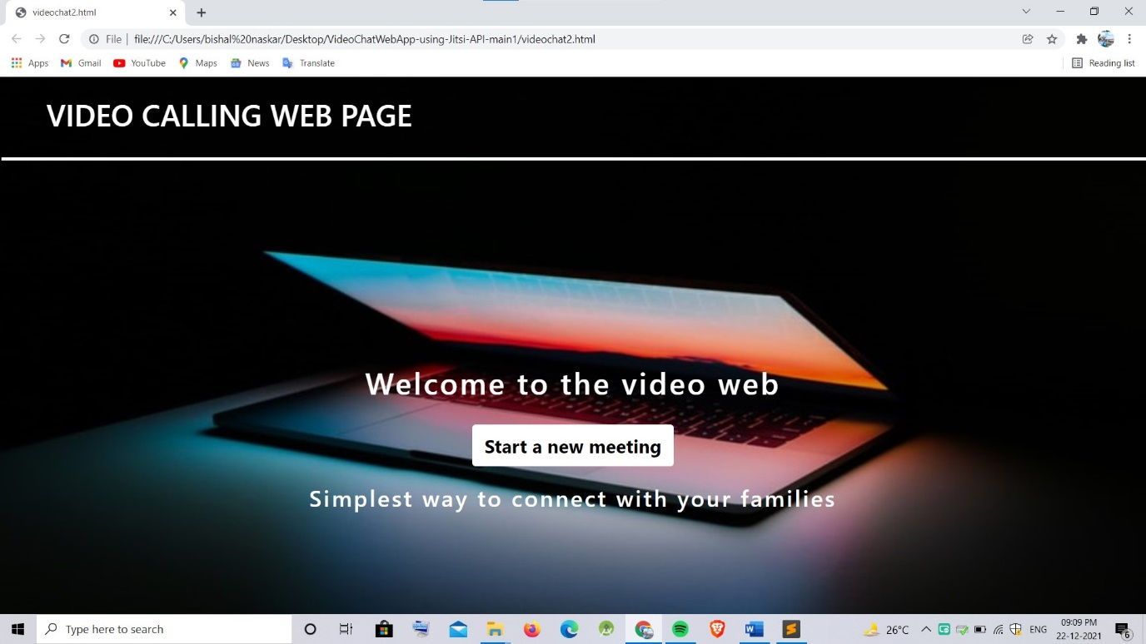

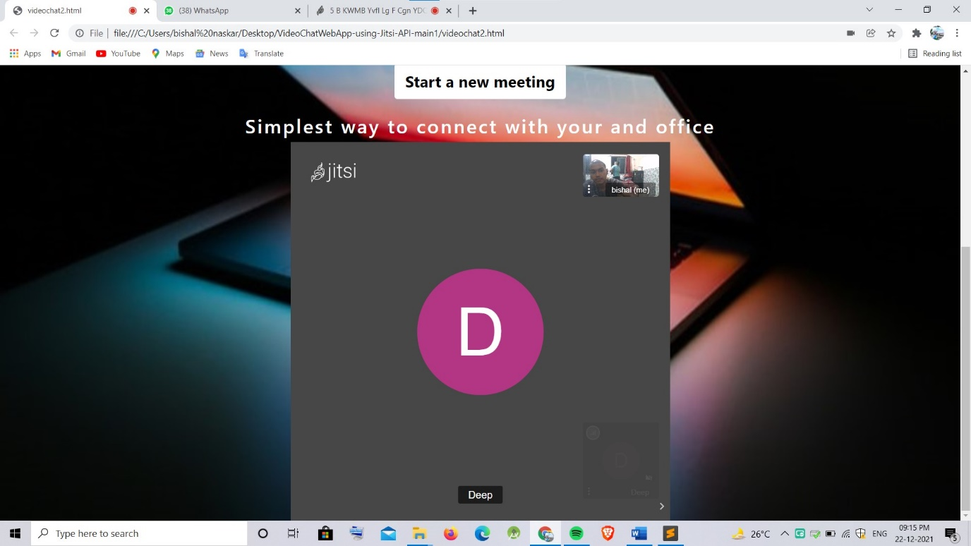

**Conclusion**

From this project one can observe that how video calling applications or web works actually, how we connect our self in the internet.

It is a fast way to interacts with different types of user, we will get to know many things about them.

From this project we learned lot of about html and css language, how to work on html, how it works and many things.

Hope this project will give us confidence in future.